EXERCISE-6 PART 2 EXPLANATION
- Relay is in the home position (receive a tone / interrupt).
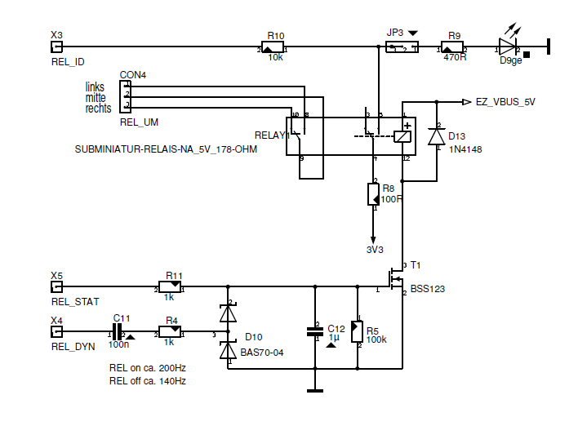
Fig 1.

2.Input signal from buzzer will be forwarded to DAC for the Generation of analog signal for the Buzzer and is then fed to comparator.

3. Buzzer signal is compared with a reference value (adjustable over
Potentiometer Fig2.), if higher, an interrupt is triggered.
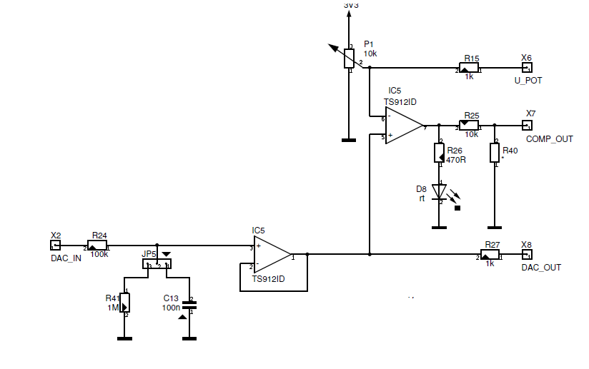
Fig 2.
4. As long as no interrupt is triggered, nothing happens.
5. Then after waiting for a time t, if (at least) one or more
Signal appears relay is switched to ‘play a tone’ mode and melody 2 is played if a signal is detected during waiting time else tone 1 is played.
6. Back to 1.

This circuit offers a crucial contrast to the previous circuit because here, by using the
Analog front-end the signal level can be achieved manually during the
operation and can be adjusted .

